|  |  |
| --- | --- |
| Site/Business Name | Dr Goyal's Dental Implants Clinic Centre |
| Site URL | <http://www.goyaldental.com/> |
| Business Page URL | <https://www.google.com/maps/place/Dr+Goyal's+Dental+Implants+Clinic+Centre/@31.3151352,75.5724121,17.83z/data=!4m5!3m4!1s0x391a5a570b11b24b:0x136be1df19116cf5!8m2!3d31.318356!4d75.577397> |
| Business Page Category | Dental clinic |
| Business’s Physical Address | 403, Lajpat Nagar, Market, Jalandhar, Punjab 144001 |

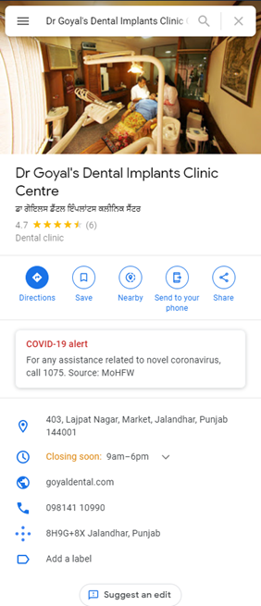

## Done Right: -

* Provides a URL to the website
* Provides a defined category “Dental Clinic”
* Same contact number and address provided on the business page as well as the business website
* Business operating time provided
* The listing included actual photos of the business and not the stock images
* The website uses the local keyword in the title tag and other SEO tags
* User reviews available

## Can be Improved: -

* Tag line/description not provided in the business listing
* Website posts/content not mentioned in the listing
* Different business timings on the website and google business page
* A business logo can be used in the Google Business Listing to enhance branding

## Suggestions: -

* Include local keywords in google business listing.
  + **Tag:** Best dental clinic in Jalandhar, Punjab
  + **Description:** Best dental and implant clinic in Jalandhar, Punjab. Get in touch to know more about our services.
* Include local keywords in website

|  |  |  |  |  |  |
| --- | --- | --- | --- | --- | --- |
| **Page** | **URL** | **Title Tag** | **Meta Description** | **H1** | **Alt Tag** |
| Home Page | <http://www.goyaldental.com/> | Dental and Implants clinic in Jalandhar, Punjab | Goyal Dental Clinic, Jalandhar | Best dental clinic in Jalandhar, Punjab. Dentist Implants Centre and Smile Designing. Goyal Dental clinic | Dr Goyal’s Dentist Clinic in Jalandhar, Punjab | Dental Clinic in Jalandhar |
| About Page | <http://www.goyaldental.com/about.html> | About Us | Goyal Dental Clinic | Best Dental Clinic and Dental Implants Centre in Punjab. Goyal Dental Clinic, Dentist in Punjab, Smile Designing, Smile Makeover in Jalandhar, Punjab India. | About Dr Goyal’s Dental and Implants Clinic | Dr Goyal’s Dental Clinic |
| Services Page | <http://www.goyaldental.com/services.html> | Dental and Implants services in Jalandhar, Punjab | Goyal Dental Clinic | Goyal Dental implants Clinic and treatment, dental veneers, dentures clinic, children's teeth, tooth whitening, bleaching clinic, gum diseases, cosmetic dentistry treatment clinic Jalandhar in Punjab. | Dental services in Jalandhar, Punjab | Dental and Implants Clinic in Jalandhar |